Speaking with PowerPoint

Designing & delivering effective presentations with PowerPoint
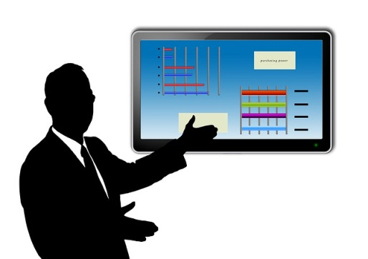


May 2016

Contents
- Keys to Successful Presentations page 3
- Speech Structure & Model Speech 1 page 4
- Speaking Practice for Presentations page 6
- Delivery Skills page 8
- Description, Logic, Critical Thinking, & Persuasion page 11
- Language of Presentations page 13
- Tips for Preparing Presentations page 15
- Logic Tree Notes page 17
- Model Speech 2: A Product Description page 20
- Rules of Design for PowerPoint page 24
- Model Speech 2 with PowerPoint page 28
- Delivery Skills for PowerPoint page 31
- Expressions for Presentations page 34


1 Keys to Successful Presentations


- There are 6 Keys to Successful Presentations

- Purpose | A successful speech has a clear purpose.  - You must have a reason for speaking and a clear message you want your audience to understand.
- Content | A successful speech has good content.  - Think about your audience: what do they know? What do they need to know? What do you have to tell them?  - Your content includes facts, analysis, and a clear message.
- Structure | Your ideas must be well organized so your listeners will understand you.  - Follow the standard speech structure to make your speech easy to understand.
- Language | Use common fixed expressions to indicate the structure of your speech. These expressions are called Flag Expressions.  - Flag Expressions help your listeners follow the structure of your speech.  - Flag Expressions tell your listeners what you are going to say.
- PowerPoint | Well-designed PowerPoint supports your presentation.  - PowerPoint highlights your main points.  - PowerPoint can also include key information and data that you want your audience to have.
- Delivery | Your delivery skills help your audience listen to you and understand you.  - You must look at your audience and speak to them.

2 Speech Structure & Model Speech 1

- Speeches have three parts
All speeches have the same three-part structure. Each part of the structure is important. They each have a specific purpose and contribute to the success of the speech.
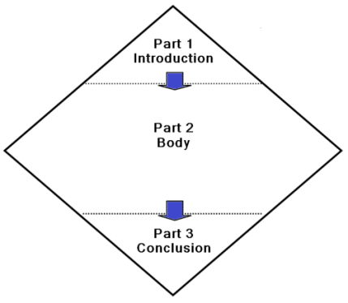

Part 1: Introduction
Purpose: Say what you are going to say.
This is the foundation of your speech:
- Greet your audience. Introduce your theme and your main points.
Get your audience interested!
Part 2: Body
Purpose: Say what you want to say.
This is the main part of your speech:
- Tell your audience everything you want them to know.
- You must select what you say: you cannot say everything about your theme – just the most important ideas linked to your message.
Keep your audience interested!
Part 3: Conclusion
Purpose: Say what you said. Deliver your message.
This is the wrap up – make a strong finish:
- Review your theme and your main points. Do not introduce any new ideas or new information.
Deliver your message. Your message is a vital part of your conclusion.
- What do you think? What do you want the audience to do?
Leave your audience thinking about your message!

- Model Speech
The model speech below is very simple; however, it illustrates the three parts of a speech: introduction, body, and conclusion. Read the structure and language of the model speech.
Self-introduction speech
- Introduction  Greetings, courtesies, & purpose | Good morning everyone. It’s a pleasure to be here. Let me tell you a little about myself.
- Body  Personal information | My name is Claus Meyer. I’m from Hamburg, Germany. I’ve been working for IMC for 15 years. I specialize in mechanical efficiency and environmental issues. I currently work in the mechanical engineering department.
Details in chronological order closing with a summary comment | I began working in IMC’s tool and die factory in Stuttgart in 2000. I worked there for 8 years. After that, I was transferred to our new factory in Kuala Lumpur, Malaysia. I went there to set up the production line and train the operators. I worked in Kuala Lumpur for 3 years. It was a very good experience.  Currently, I work in the mechanical engineering department in Stuttgart. I supervise the design of new equipment.
Summary comment | I really enjoy my work at IMC and my career so far has been very interesting.
- Conclusion  Closing courtesies | I am very happy to be here today and I am looking forward to working with you all. Thank you.
- Exercise: Write your self-introductory speech. Follow the same structure and use the same expressions as the model.
You can expand your introduction with some of the points below:
- Why I joined my company.
- The work I have done and the work I am currently doing.
- The work I have enjoyed the most and why.
- What I would like to do in the future and why.

Note about Vocabulary for Work
- Don’t say, “I’m in charge of…” unless you are the boss. Say, “I take care of…”
- Don’t say, “I belong to the general affairs department.” Say, “I work in the general affairs department.”
3 Speaking Practice for Presentations

- 7 Elements for Speaking Clearly
In addition to good pronunciation and overcoming katakana, English has other elements for clear speaking. These elements make your words easier to understand and give meaning to your words. Without the elements it can be difficult to understand the speaker’s meaning.
The elements are common to native speakers of English; however, how they are used varies from speaker to speaker. The samples below are just one way to apply the elements. Practice out loud and you will learn how to use the elements to speak more clearly.
The Elements Voice Symbols
- Speak slowly. Say each word carefully.
- Lengthen some vowels slightly: a, e, i, o, u
- Speak in groups of words & pause slightly between them: / (short pause)
- Pause between sentences: // (medium pause)
- Pause between paragraphs: /// (longer pause)
- Stress key words and pause before & after them: Stress key words
- Speak with intonation –rising, falling & flat:

- The 7 Elements: Samples & Application
Samples: Practice each of the 7 Elements for Speaking Clearly by saying the passage carefully out loud at least three times: the more the better.
Application: After practicing the samples below, apply each element to your own speech text and practice.
- Speak slowly. Say each word carefully.
Good morning everyone. It’s a pleasure to be here. Let me tell you a little about myself.
My name is Claus Meyer. I’m from Stuttgart, Germany. I’ve been working for IMC for fifteen years.
- Lengthen some vowels slightly for clarity.
Good morning everyone. It’s a pleasure to be here. Let me tell you a little about myself.
My name is Claus Meyer. I’m from Stuttgart, Germany. I’ve been working for I M C for fifteen years.

- Speak / in groups of words / & / pause slightly / between the groups.
- Pause between sentences. //
- Pause between paragraphs. ///
Good morning / everyone. / It’s a / pleasure / to be here. // Let me tell you / a little / about myself. ///
My name is / Claus / Meyer. I’m from / Stuttgart, / Germany. //
I’ve been working for / I/M/C / for / fifteen / years. //
- Stress key words & pause before & after key words
Good morning everyone. It’s a pleasure to be here. Let me tell you a little about myself.
My name is Claus Meyer. I’m from Stuttgart, Germany. I’ve been working for I M C for fifteen years.
- Speak with intonation – the voice rising and falling.
Good morning everyone. It’s a pleasure to be here. Let me tell you
a little about myself.
My name is Claus Meyer. I’m from Stuttgart, Germany. I’ve been
working for I/M/C for fifteen years.

- The 7 Elements Together: A Sample
After practicing the individual elements out loud, practice all 7 elements together. Many times!
Good morning / everyone. It’s a pleasure / to be here. // Let me tell you
a little about myself.///
My name is / Claus Meyer. // I’m from / Stuttgart, / Germany. I’ve been
working for / I/M/C for / fifteen years.//

And then practice the 7 elements of speaking clearly with your own speech script. Many, many times!

4 Delivery Skills
- Good delivery skills are essential for a good presentation.
Good delivery skills build your confidence and win the attention of your audience.
- Stand up and practice the skills.
- Your teacher will model each of these skills for you one-by-one.
- Practice the skills until they are easy to do.

Eye Contact

Voice

Gestures
Clothing
Posture

Speak to your audience. Deliver your message.

- Voice
Your voice is your most important delivery skill.
- A clear strong voice delivers your message to your audience. If they cannot hear you they will not receive your message.
- Speak smoothly and without hesitation.
- Don't rush or speak too quickly.
- Emphasize important words and phrases.
- Eliminate the unnecessary pauses and Ummmms.

- Eye contact
Eye contact connects the speaker and the audience.
- Look at your audience, not at your notes.
- Look at the whole audience. Move your head so you can make eye contact with everyone.
- Memorize parts of your speech so you can look at your audience. Memorize your greetings, introduction, transition to each main point, and your closing thoughts.

- Posture
Good posture makes you appear more confident.
- Position yourself so you can see your audience and your audience can see you.
- Stand up straight with your feet slightly apart and your weight evenly on both feet.
- Don't lean on the table or lectern.

- Gestures
Gestures are an important part of your delivery. During your presentation your hands should be holding your notes, gesturing or pointing at your PowerPoint.
- Gestures add emphasis and rhythm to your presentation.
- Good gestures are small, firm, and clear. Big gestures are not appropriate.
- When you gesture, look at your audience: If you are not looking at your audience, do not gesture.
- When you count (1st, 2nd, 3rd), you can gesture with one finger, two fingers, three fingers.
- But, if you say, "My next point is…" or "My last point is…" - don’t count with your fingers.
- Don't scratch your face or play with your hair.
- Don’t cover your face with your hand if you adjust your glasses.

- Clothing – appropriate and neat
Be sure your clothing is neat and appropriate for the situation.
- Before your meeting check your appearance - your tie, your jacket collar, and your hair. Make sure everything is neat.
- Inappropriate or messy clothing will distract your audience’s attention away from your message.

- Speaking notes
If you use a speaking script or notes make sure they are clear and easy to read.
- Hold your notes in your hand: Don't put them on a table or lectern – You will look down at them and not look at your audience!
- Hold your notes in one place just above your waist where they are easy to see.
- Don’t move your notes: it’s very distracting!
- Hold your notes in the middle of the page so they won’t fold over.

- Standing still or moving
- In very formal presentations and with small groups it is best to stand in one place.
- With a more informal presentation with a large audience it is good to move so you can speak directly to different sections of the audience and create better communication.

5 Description, Logic, Critical Thinking, & Persuasion
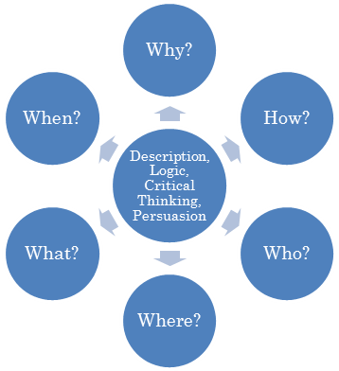

- Effective presentations
Effective presentations include description, logic, critical thinking and persuasion. The model speech in Unit 9 is an example of all four of these elements.
- Four elements for effective presentations
The four elements of effective presentations (description, logic, critical thinking, and persuasion) use the Wh Questions. The Wh Questions are not just points of grammar. Wh Questions are the tools we use to understand and organize information.
- Description
Description uses the questions who, where, what, when, and how to create a picture with words. When a description is successful, the audience should be able to see an image in their minds.
- Effective description requires understanding the audience and speaking to that audience.
- The speaker must give all the necessary details to the audience. The speaker cannot expect the audience to guess the meaning or fill in the gaps in information. Expressions such as “and so on” and “etc.” are meaningless.
- Effective description is well organized; it requires logic.
- Logic
Logic is the systematic organization of facts and analysis in order to present a clear conclusion and message.
- The three-part structure of a speech is a logical structure:
  - Introduction: Tell your audience what you are going to say.
  - Body: Tell your audience what you want to say.
  - Conclusion: Tell your audience what you want them to understand and do.
- Logic is created with common grammatical structures that compare, contrast, or connect. For example:
- Same as …  - Similar to …  - Different from …  - Larger than  - Smaller than | - Now/Currently…  - Before …  - During …  - After …  - Then …  - Next …  - Meanwhile | - If … then…  - Unless …  - Because…  - Since… | - Due to…  - Despite…  - Therefore …  - So…  - But …  - However,…
- An example of logic from the model speech in Unit 9, Paragraph 9. The model speech is about a new car called the Ventura.
- Statement: the Ventura is environmentally responsible.
- Evidence/facts: With its efficient hybrid engine and ultra-low emissions,
- Analysis: it far exceeds the government’s targets.
- Evidence/fact: In addition, 95% of the car is made of recyclable material.
- Conclusion: So, totally, the Ventura is an environmentally responsible car.
- Critical thinking
Basically, critical thinking is a logical process of asking and answering the question, Why? We can identify six steps in the process of critical thinking:
- Gather facts and understand a situation.
- Separate the main ideas from the details.
- Separate fact from opinion.
- Bring the facts together in a description of the situation.
- Analyze and evaluate the facts. Look for connections between them.
- Draw conclusions from the facts, analysis, and evaluation.
- Persuasion
Persuasion is the ability to get an audience to understand and accept an idea. Persuasion requires description, logic, and critical thinking.
- Three Elements of Persuasion:
- The speaker must seem believable and logical about the subject.
- The speaker must help the audience make an emotional connection to the subject.
- The speaker must give the audience enough information about the subject so the audience can understand it and accept the conclusion.
- Five Stages of Persuasion
  - Get the audience’s attention so they want to listen.
  - Describe the situation so the audience feels action is required.
  - Make a proposal that will satisfy the need for effective action.
  - Create an image of the results of the proposal so the audience will feel they will get some benefit from the action.
  - Make a specific request to the audience to act so the proposal is successful.

6 Language of Presentations


- Flag Expressions
- Flag Expressions are special expressions that introduce each step in the structure of your speech.
- Flag Expressions are like a tour guide’s flag: Everyone can follow the guide’s flag and not get lost. If there is no flag the guide is too hard to follow.
- Memorize and use the Flag Expressions. They will help you organize your information and ideas, and express yourself clearly.

Parts | Purpose | Flag Expressions
Part 1:  Introduction | - Appreciate the introduction |  | Thank you for the introduction, (Mr. Chairman).
Part 1:  Introduction | - Greet the audience |  | Good evening, everybody.
Part 1:  Introduction | - Give your theme |  | Today, I am going to tell you about …
Part 1:  Introduction | - Give your main points |  | I have three main points.
Part 1:  Introduction |  |  | First,*
Part 1:  Introduction |  |  | Second, |  | I will talk about…
Part 1:  Introduction |  |  | Third,
Part 1:  Introduction |  |  | *Note: Never say At first. It is not correct.
Part 2:  Body | - Start the body | Let me begin with my first point.
Part 2:  Body | - Start the second point | Now*, I’ll move on to my second point.
Part 2:  Body | - Start the third point | Finally, I will tell you my third point.  *Note: Now & Next are correct but do not use Then. Then is not correct in this situation.
Part 3:  Conclusion | - Review | In conclusion, let me review my main points.
Part 3:  Conclusion | - Review |  |  | First,
Part 3:  Conclusion | - Review |  |  | Then, | I talked about….
Part 3:  Conclusion | - Review |  |  | Finally,
Part 3:  Conclusion | - Your Message | I think that… (*Never begin with Let’s…)  Thank you. (*Never say That’s all.)  And now, I will be happy to answer your questions.
Part 3:  Conclusion | - Close
- Notes About Flag Expressions
- Counting Vs Transitions
In the introduction and conclusion you can count your main points with First, second, third; or First, then, next, finally.
However, in the body these words are not correct for introducing the main points.
In the body, introduce each point with transition expressions such as -
- Let me begin with my first point.
- Now/Next, I’ll move on to my second point.
- Finally/Now, I will tell you my third point.
- Use at first correctly
Do not use at first to count or to introduce your first point.
- At first is a different grammatical structure from counting: first, second, third.
- At first introduces a condition that is going to change. For example:
When I went to Canada, at first it was very difficult for me to speak English, however, after awhile it became much easier for me.
- Use Let’s correctly
Let’s is suitable only for informal proposals such as -
- Let’s get started.
- Let’s take a short break.

Let’s should not be used for formal proposals and conclusions.
For example-
- Let’s improve our products and advertising. Not appropriate.
- I think we need to improve our products and advertising. Appropriate.

7 Tips for Preparing Presentations



- Preparing Your Speech
Prepare your speech systematically.
- Prepare your speech in English
Don’t prepare it in Japanese and then translate it.
- Writing in Japanese and then translating is a waste of time and the results will not be very good.
- Think about your topic in English and write your notes in English.
- Think about why you are speaking
What is the purpose of your speech?
- What is your message?
- Think about your audience
Who is your audience?
- What do they need to know?
- Write your speech
Write in simple clear English.
- Follow the basic structure.
- Use the flag expressions.
- Be logical & persuasive.
- Prepare your PowerPoint slides
Follow the design rules.
Check the design by printing or projecting your PowerPoint.
- Practice your presentation (speech + PowerPoint)
Practice your presentation.
- Practice delivering your presentation out loud with the delivery skills.
- Make changes and corrections.
- Practice again.

- PowerPoint
Handouts: Print copies of your PowerPoint handout.
- Put them in a folder to protect them.
PowerPoint Slides
- Carry a backup copy on a thumb drive / flash memory stick.
- E-mail it to yourself for back up.
- Take hardcopies for extra backup.

- Speaking Notes & Speech Text
      - Speaking Notes
- If you write speaking notes on cards, make sure the words are large and easy to read.
      - Speech Text
- Prepare a neat copy of your speech text.
- Make sure your text is easy to read with wide margins on the top, bottom, and sides as in Sample A below. Sample A is much easier to read than Sample B.
- Don’t add last minute changes to your text. You will not be able to read disorganized notes during your presentation.
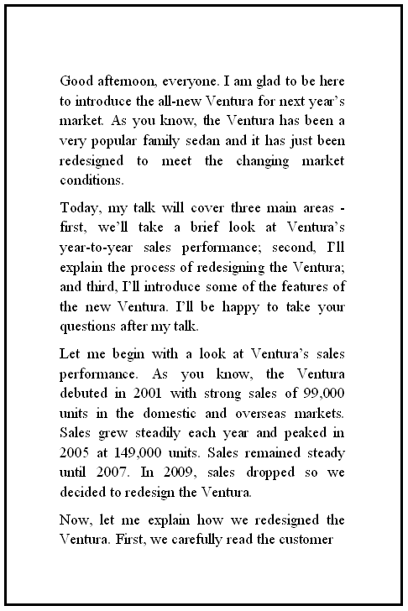
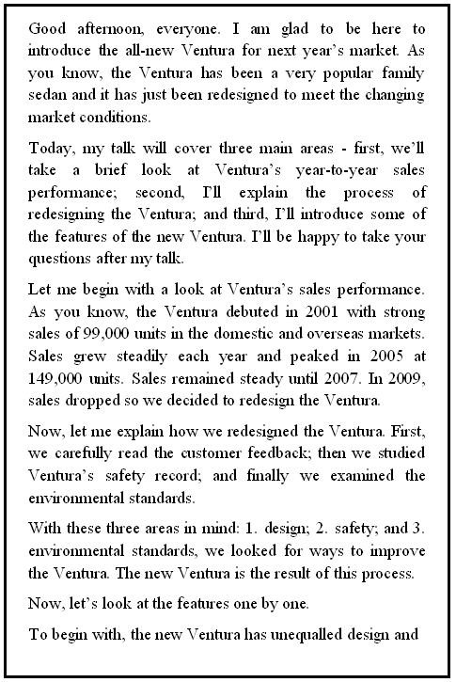

Sample A: Easy to read |  | Sample B: Not Easy to Read

8 Logic Tree Notes

- What is a Logic Tree?
When you make notes for your speech, use a logic tree.
A Logic Tree is like a chart. It is an easy way to organize and remember your ideas because it has a place for each part of your speech: the theme, main points, details for each point, and your message.

- Why is your speech like a tree?
Can you name the parts of the tree?




Roots | The roots of your speech are your preparation.  - Strong roots make a strong tree.  - Good preparation makes a good presentation.
Trunk | The trunk is the theme or main idea of your speech.  - Everything in your speech must be connected to the theme.
Branches | The branches are your main points. Three is a good number.  - All your main points must come from the theme.
Leaves | The leaves are your details, numbers, and examples.  - They explain your main points and make your speech interesting.
Fruit | The tree’s fruit is your message.  - Your message is what you want your audience to take away and think about.  - Without a clear message your speech has no purpose.

- Logic Tree Sample 1
Below is a Logic Tree for speech notes: the theme is on the left, followed by the main points and supporting details; finally, the message is on the right. Extra lines can be added if needed.
The Logic Tree is a very useful tool. By writing your speech notes in this pattern, it is easy to organize your ideas and information. Your speech will be complete and you won’t forget anything. With your notes in a Logic Tree, it will be easy to visualize and remember your whole speech from beginning to end.

Parts of a Logic Tree
Trunk | Branches | Leaves | Fruit

 |  |  |  |  | Supporting Detail 1 for Point 1 |  | Message
 |  |  | 1st Main Point |  | Supporting Detail 2 for Point 1 |  | Message
 |  |  |  |  | Supporting Detail 3 for Point 1 |  | Message
 |  |  |  |  | Supporting Detail 1 for Point 2 |  | Message
Theme |  |  | 2nd Main Point |  | Supporting Detail 2 for Point 2 |  | Message
 |  |  |  |  | Supporting Detail 3 for Point 2
 |  |  |  |  | Supporting Detail 1 for Point 3
 |  |  | 3rd Main Point |  | Supporting Detail 2 for Point 3
 |  |  |  |  | Supporting Detail 3 for Point 3

- Logic Tree Sample 2
Below is a Logic Tree for a presentation to introduce a new car called the Ventura. You can find the complete text of the speech in Unit 8 and with PowerPoint in Unit 10.

Theme | Main Points | Details | Message

 |  |  |  |  | 1.Strong debut sales - 2001 |  | The New Ventura will exceed previous sales
 |  |  | 1. Sales performance |  | 2. Steady growth - peaks |  | The New Ventura will exceed previous sales
 |  |  |  |  | 3. New designs |  | The New Ventura will exceed previous sales
 |  |  |  |  | 1. Reviews & feedback |  | The New Ventura will exceed previous sales
 |  |  |  |  | 2. Safety record |  | The New Ventura will exceed previous sales
New Ventura |  |  | 2. Redesign |  | 3. Environmental standards |  | The New Ventura will exceed previous sales
 |  |  |  |  | 1. Design & comfort - fun
 |  |  | 3. Features |  | 2. Safety - equipment
 |  |  |  |  | 3. Environmentally responsible
 |  |  |  |  | 4. Emissions, hybrid recycle
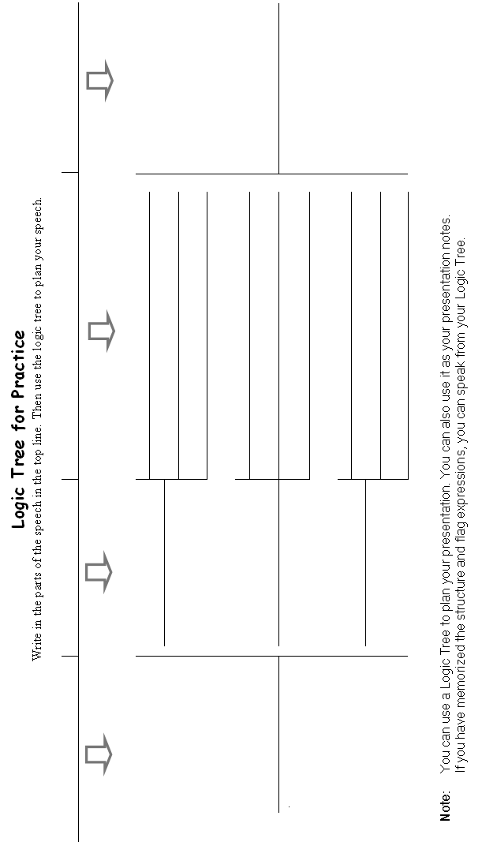
9 Model Speech 2: A Product Description

- Model Speech 2: Product Description
Below is a product description for an in-company meeting. It includes elements of description, logic, persuasion, and critical thinking.
- Background to the model speech
The speaker is Steve Ridley, the head of a design team at Prestige Motors, a large car manufacturer. In this presentation, Mr. Ridley introduces the new model of the Ventura to the marketing team.
- Instructions
Read and practice the speech. Identify the structure, flag expressions, theme and conclusion and examples of description, logic, critical thinking, and persuasion. You can use this speech as a model for your own speeches.
Text | Your Notes
1. Good afternoon, everyone. I am glad to be here to introduce the all-new Ventura for the 2014 market. As you know, the Ventura has been a very popular family sedan and it has just been redesigned to meet the changing market conditions.
2. Today, my talk will cover three main areas - first, we’ll take a brief look at Ventura’s sales performance; second, I’ll explain the process of redesigning the Ventura; and third, I’ll introduce some of the features of the new Ventura. I’ll be happy to take your questions after my talk.
3. Let me begin with a look at Ventura’s sales performance from 2000 to 2013. The Ventura debuted in the year 2000, with strong sales of 152,300 units in the domestic market. Sales grew steadily each year and peaked in 2003 at 235,500 units. In 2006, sales dropped sharply to 221,800 units so we decided to update the design. With the new design sales recovered dramatically in 2008 and peaked in 2010 at 249,900 units. By 2012, sales had dropped to 234,100 units so we decided to remodel the Venture again for the 2014 market.
4. Now, let me explain how we redesigned the Ventura. First, we carefully read customer feedback; then we studied Ventura’s safety record; and finally we examined the environmental standards.
5. With these three areas in mind: 1. design; 2. safety; and 3. environmental standards, we looked for ways to improve the Ventura. The new Ventura is the result of this process.
6. Now, let’s look at Ventura’s features one by one.
7. To begin with, the new Ventura has unequalled design and comfort. Its sporty design, powerful 3-liter engine, and spacious interior make the new Ventura fun to drive.
8. The second feature is safety. Ventura’s improved safety features include a stronger frame; an advanced Collision Avoidance System that warns about dangers; and an Integrated Crash Protection System of upgraded airbags and seat belts that provides full protection. The Ventura is a very safe car to drive.
9. Finally, the Ventura is environmentally responsible. With its efficient hybrid engine and ultra-low emissions, it far exceeds the government’s targets. In addition, 95% of the car is made of recyclable material. So, totally, the Ventura is an environmentally responsible car.
10. In conclusion, I would like to say that because of these features - its design, safety, and environmental responsibility - we are confident the new Ventura will recover its position as a leading high performance family sedan and exceed its past sales performance.
11. Thank you for listening.
Now, I’ll be happy to answer your questions. …
Yes, Mr. Watson?

- Analyzing the structure and language of Model Speech 2
Notes | Text
Introduction  Greetings >  Courtesy >  Topic >  Background >  Flag expression for time >  Introducing 3 main points >  Main Point 1 >  Main Point 2 >  Main Point 3 >  When to ask questions >  Body  Transition to Main Point 1 >  Details >  Cause >  Result >  Transition to Main Point 2 >  Details >  Conclusion: 3 main details >  Message for Main Point 2 >  Transition to Point 3 >  Introducing the details >  Starting 1st Feature >  Conclusion & Message >  Transition to 2nd Feature >  Details >  Conclusion & Message >  Transition to 3rd Feature >  Details >  Conclusion & Message >  Conclusion  Transition to the Conclusion >  Review of main features >  Message of the speech >  Closing with appreciations >  Opening for questions >  Responding to a question > | 1. Good afternoon, everyone.  I am glad to be here  to introduce the all-new Ventura for the 2014 market.  As you know, the Ventura has been a very popular family sedan and it has just been redesigned to meet the changing market conditions.  2. Today,  my talk will cover three main areas –  first, we’ll take a brief look at Ventura’s sales performance;  second, I’ll explain the process of redesigning the Ventura;  and third, I’ll introduce some of the features of the new Ventura.  I’ll be happy to take your questions after my talk.  3. Let me begin with a look at  Ventura’s sales performance from 2000 to 2013. The Ventura debuted in the year 2000, with strong sales of 152,300 units in the domestic market. Sales grew steadily each year and peaked in 2003 at 235,500 units.  In 2006, sales dropped sharply to 221,800 units  so we decided to update the design.  Sales recovered dramatically in 2008 and peaked in 2010 at 249,900 units.  By 2012, sales had dropped to 234,100 units so  we decided to remodel the Venture again for the 2014 market.  4. Now, let me explain how  we redesigned the Ventura.  First, we carefully read customer feedback; then we studied Ventura’s safety record; and finally we examined the environmental standards.  5. With these three areas in mind: 1. design; 2. safety; and 3. environmental standards,  we looked for ways to improve the Ventura.  The new Ventura is the result of this process.  6. Now, let’s look at  Ventura’s features one by one.  7. To begin with,  the new Ventura has unequalled design and comfort. Its sporty design, powerful 3-liter engine, and spacious interior make  the new Ventura fun to drive.  8. The second feature is  safety.  Ventura’s improved safety features include a stronger frame; an advanced Collision Avoidance System that warns about dangers; and an Integrated Crash Protection System of upgraded airbags and seat belts that provides full protection.  The Ventura is a very safe car to drive.  9. Finally,  the Ventura is environmentally responsible. With its efficient hybrid engine and ultra-low emissions, it far exceeds the government’s targets. In addition, 95% of the car is made of recyclable material. So, totally, the Ventura is an environmentally responsible car.  10. In conclusion,  I would like to say that because of these features - its design, safety, and environmental responsibility -  we are confident the new Ventura will recover its position as a leading high performance family sedan and exceed its past sales performance.  11. Thank you for listening.  Now, I’ll be happy to answer your questions. …  Yes, Mr. Watson?

- Exercise 2
Use Model Speech 2 as a template for your own speech about your work.
- Choose the parts of the model that you want to use in your speech. Follow the structure and use the flag expressions.
- Practice your speech out loud with delivery skills before you present it.
10 Rules of Design for PowerPoint

- Design Rules for PowerPoint
There are two key words for PowerPoint: Simple and Clear.
- PowerPoint that is simple and clear will help deliver you message.
- Poorly designed PowerPoint will confuse and bore your audience. This will not help you deliver your message.

- Structure of PowerPoint Presentations
PowerPoint presentations should include the following four parts:
    - Title Slide
Begin your PowerPoint presentation with a simple title slide with:
- Title of your presentation.
- Date of the presentation
- Name of the organization or company you are presenting to.
- Your company’s name.
- Your name (optional).
    - Index Slide
The index is a list of your main points.
- You will need an index if your PowerPoint has 5 or more pages of information.
- Use the page titles in the index.
- If your PowerPoint has 4 or fewer pages of information, a content page is probably not necessary.
    - Content Slides
This is the main part of your PowerPoint. You will need one or two slides for each main idea.
- Follow the design rules below.
    - Conclusion Slide
The last page is the Conclusion slide.
- The conclusion highlights the message of your presentation.
- See Unit 10 for Speech Model 2 with PowerPoint.

- Design Points to Consider
- Template | Choose a simple template  - Use your company’s PowerPoint template or choose a template from PowerPoint Design (a drop down menu on the PowerPoint tool bar).  - Choose carefully: Most templates are not suitable for business presentations.  - Avoid fancy designs with maps, flowers, or pictures. Fancy templates will distract from your message.  - Don’t use images just because they are cute or pretty. If the image is not connected to the theme of your presentation it is a meaningless distraction.
- Colors | Be careful with colors  - Avoid colors that are too bold, too bright, or too pale.  - Caution: Colors on the computer screen appear differently from how they will appear when printed or projected. Always test print or test project your slides to check the colors. Change them if necessary.
- Font Style  See the note about fonts on page 25. | Choose plain fonts: they are easy to read  - Titles & section headings: Choose a san-serif font for the headings. Arial is recommended.  - Text: Choose a serif font for the text. Times New Roman or Georgia are recommended  - Do not use:  - Century font: The punctuation looks unusual.  - Script fonts: Script fonts are hard to read.  - Italics: Italics are only for emphasis.  - All UPPER CASE: It is unpleasant to look at. It looks like shouting!
- Font size for projection  Note: Font size is measured in points. | Make your text easy to read  - Titles and text should be big and easy to read.  - Titles should be big: 44 points is good.  - Section Headings should be 36 or 34 points.  - Text should be easy to read: 30 or 28 points.  - Don’t use anything smaller than 24 points.  Small text has no value. Your audience won’t be able to read it.
- Font size for handouts | Make your text easy to read  - Titles should be 30 or 28 points.  - Headings should be 24 or 20 points.  - Text should be at least16 points.  - This line is 12 points: 12 points is the smallest size recommended for PowerPoint handouts.
- Text Layout | Layout details are important  - Slides with wide margins at the top, bottom, and sides easier to read.  - Do not put headings or text in the area at the top or bottom of the slide reserved for the company logo.  - Keep indentation and spacing regular. Irregular indentation and spacing are distracting.  - Do not use brackets < > in titles.  - Number the pages for handouts.
- The Rule of 1 | The Rule of 1: 1 idea per slide  - Your slides must be clear and easy to read.  - Don’t put too much information onto one slide:  - Projected PowerPoint should highlight your main points.  - Do not put your complete speech text in projected PowerPoint. You can put it in a handout if needed.
- The Rule of 7 | The Rule of 7  - Maximum 7 lines of text per slide.  - Maximum 7 words per line.  - Try to keep titles and section headings to one line. Long headings are difficult to read.  - Avoid articles and prepositions.  - Use lists and numbers.  - Eliminate repeated words in lists.
- Animation, Sweeps, & Sounds | Simple is best:  - Avoid animation and sweeps for slide changes. They are not necessary and can be distracting.  - Don’t use sounds at all.
- Check your PowerPoint!
Before presenting your PowerPoint, check it carefully. Look at it as your audience will look at it.
  - Projected PowerPoint: project your PowerPoint on a wall screen. Don’t just look at it on the computer screen. Computer color and projected color do not look the same.
  - PowerPoint handout: print your PowerPoint to check the color and layout.
  - Check these points:
- Are the colors attractive, clear, and easy to look at?
- Does the text look balanced on the page?
- Can you see all the words clearly?
- Is it easy to see the main points?
- Will your audience understand them easily?
- Check the spelling and punctuation.
- Check the margins, indentation, and spacing.

- A Note About Serif and Sans-serif Fonts
1. Serif Fonts- Aa Bb Cc  - Serifs are the little feet at the end of the stroke.  - Serif fonts are easy to read so they are used for text: newspapers, magazines, books and business letters. | A
2. Sans-serif Fonts - Aa Bb Cc  - Sans is French for without. Sans-serif fonts do not have the little feet at the end of the stroke.  - Sans-serif fonts are used for posters, titles, and short phrases - they are not as easy to read on paper.  - Sans-serif fonts are easier to read on computers and Websites and are commonly used for e-mail and texting.  - Sans-serif fonts are informal and not suitable for business letters. | A

11 Model Speech 2 with PowerPoint
- PowerPoint slides for Model Speech 2
Slide 1: Title Slide  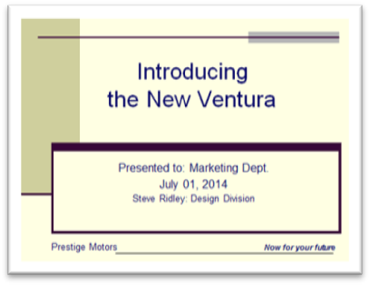  Slide 2: Index Slide  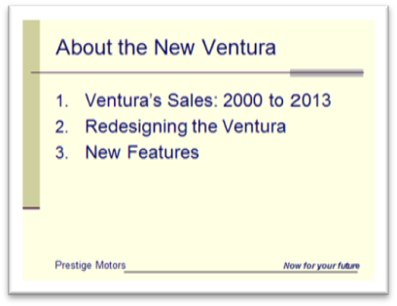  Slides 3 to 8: Contents  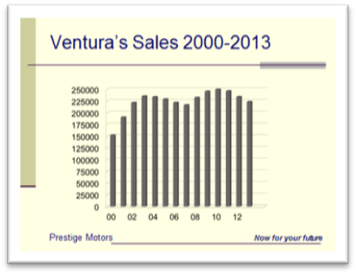 | Note (Pt) means pointing at the slide.  Good afternoon, everyone. I am glad to be here to introduce the all-new Ventura for the 2014 market. As you know, the Ventura has been a very popular family sedan and it has just been redesigned to meet the changing market conditions.  Today, my talk will cover three main areas. (Go to slide 2)  First, (Pointing to slide 2) we’ll take a brief look at Ventura’s sales performance; second, (Pt) I’ll explain the process of redesigning the Ventura; and third, (Pt) I’ll introduce some of the features of the new Ventura. I’ll be happy to take your questions after my talk.  Let me begin with a look at Ventura’s sales performance. (Go to slide 3)  This slide shows Ventura’s sales (Pointing at the year and number axis.) The Ventura debuted in 2000 with strong domestic sales of (Pt) 152,300 units. (Pt) Sales grew steadily each year and peaked in (Pt) 2003 at 235,500 units. In (Pt) 2006, sales dropped sharply to (Pointing) 221,800 units so we decided to update the design.  With the new design sales recovered dramatically in 2008 (Pt) and peaked in 2010 at 249,900 units. (Pt) By 2012, sales had dropped to 234,100 units (Pt) so we decided to remodel the Venture again for the 2014 market.  Now, let me explain how we redesigned the Ventura. (Go to slide 4)
Slide 4  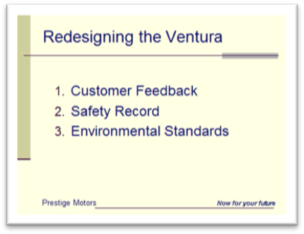  Slide 5  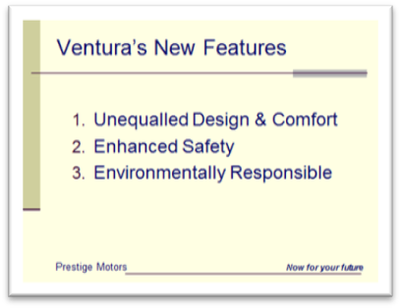  Slide 6  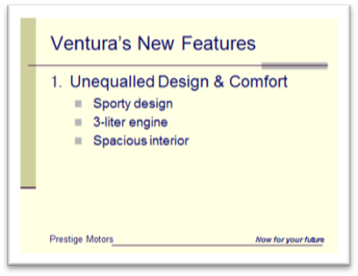  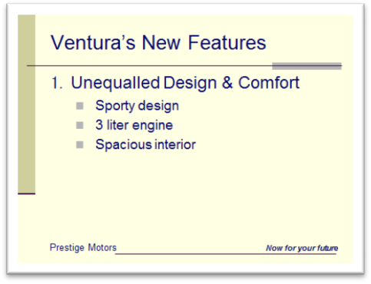  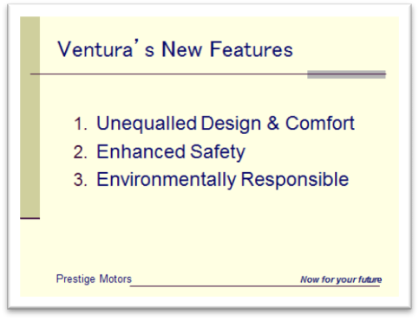 | First, we carefully read (Pt) Ventura’s customer feedback; (Pt) then we studied Ventura’s safety record; and finally (Pt) we studied the environmental standards. (Go to slide 5)  With these three areas in mind,  (Pt) 1. design, (Pt) 2. safety, and  (Pt) 3. environmental standards, we looked for ways to improve the Ventura. The new Ventura is the result of this process. Now, let’s look at the features one by one. (Go to slide 6)  To begin with, the new Ventura has  (Pt) unequalled design and comfort. Its (Pt) sporty design, (Pt) powerful 3-liter engine, and (Pt) spacious interior make the new Ventura fun to drive. (Go to slide 7)

Slide 7  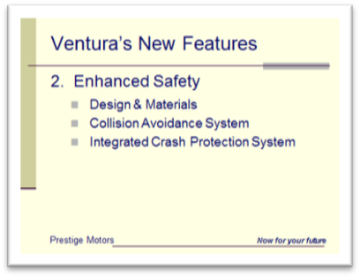  Slide 8  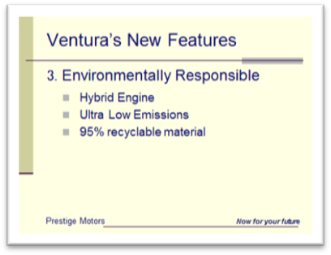  Slide 9: Conclusion Slide  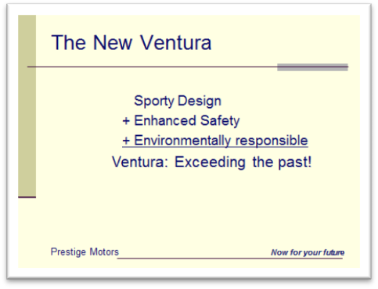  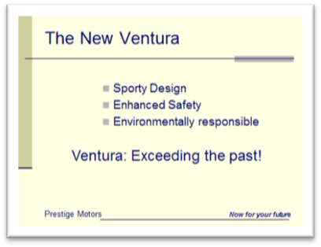 | The second feature is (Pt) safety. Ventura’s improved safety features include a stronger frame; (Pt) an advanced Collision Avoidance System that warns about dangers; and (Pt) an Integrated Crash Protection System of upgraded airbags and seat belts that provides full protection. The Ventura is a very safe car to drive. (Go to slide 8)  Finally, the Ventura (Pt) is environmentally responsible. With its (Pt) efficient hybrid engine and (Pt) ultra-low emissions, it far exceeds the government’s targets. In addition, (Pt) 95% of the car is made of recyclable material. So, totally, the Ventura is an environmentally responsible car. (Go to slide 9)  In conclusion, I would like to say that because of these features - its  (Pt) design, (Pt) safety, and (Pt) environmental responsibility - we are confident the new Ventura will recover its position as a leading high performance family sedan and exceed its past sales performance. (Leave the last slide on the screen)  Thank you for listening.  Now, I’ll be happy to answer your questions.  Yes, Mr Watson?

12 Delivery Skills for PowerPoint

- Slides Vs. Handouts
- Presenting PowerPoint as projected slides is very effective for a large audience.
- Giving PowerPoint handouts can be very effective for a small audience of 1 to 5 people.
- There are different delivery skills for projection and handouts.

- Speaking with PowerPoint Slides
- Speaking Position
- Stand at the front near the screen so you can see your audience and your audience can see you.
- You can move from one side of the screen to the other if you need to.
- Speaking notes
- Do not read the projected PowerPoint.
- Do not read your presentation from the computer screen. You will be looking down, not at your audience. They will think you are not prepared and don’t know what you are talking about.
- Speak to your audience: Speak from memory or speak from notes in your hand.
- Pointing and speaking
- Point and look at the screen then turn and speak to your audience: Do not look at the screen and speak to the screen.
- Point to the screen with your inside hand, the one closest to the screen. If you point with your outside hand, you will turn your back to your audience.
- Point to the screen with your hand or a pointer stick. Avoid using infrared pointers: they are dangerous to eyes and the red dot on the screen always moves so it is hard to look at.
- Changing the slides
- If you control the slide changes from a computer, make sure it is close and convenient.
- If you use a remote control, hold it in one hand.
- Test all the equipment before your presentation begins.
- Presenting PowerPoint
- Have your title slide on the screen before you begin.
- Show your charts and graphs only when you need them.
- Don't show them before you speak about them.
- Don't leave them up too long.
- Introduce the slide when it comes on the screen by giving the title, explaining any symbols, and pointing at and explaining the key points.
- The audience will not be able to understand your chart until you introduce it.
- During the Q&A leave your conclusion slide on the screen.

- Speaking with PowerPoint Handouts
- Sit where you can see your whole audience and they can see you.
- Sit up straight at the front of your chair.
- Don’t distribute your handouts until you are going to use them.
- If you give the handout too soon, your audience will look at the handout and ignore you.
- Introduce your presentation briefly then, when you are ready to use it, distribute the handout to the audience.
- Hold your handout so everyone can see it. Point to the item you are talking about.
- Speak to your audience: Do not read your handout to your audience.
- Tell your audience what page to look at and when to turn the page: keep your audience looking at the correct page and focused on your message.
- Introduce each page: What is it? What is the message of the page?
- When you finish each page, confirm the message before going to the next page.

- Language for PowerPoint Handouts
- Introduce and distribute your handouts
- I’ve prepared some material to illustrate my presentation.
- You can take notes on this if you like.
- Go to the content page
Introduce the structure of your presentation.
- Please turn to page 2.
- This is an outline / overview of my presentation.
- Going from page to page
- Please …  - Let’s … | - turn to …  - go to … | - the second page.  - page two.  - the next page.
- Introduce each page
- As you can see …
- This page describes …
- This chart shows …
13 Expressions for Presentations
Study the following expressions.
Read them aloud and mark them – A, P or N:
- A for Active You already use the expression.
- P for Passive You know what the expression means but you don’t use it.
- N for New You have never seen the expression before.
Look for passive and new expressions you can use in your presentations.

- Expressions of Order (1, 2, 3)
Counting and using numbers gives order to your speech.
- I have three points: First, … Second, … And third, …
- Firstly, secondly, thirdly (less common but also acceptable.)
Note: Do not say “At first”. It is not correct for counting.

- Let me begin with my first point.
- First, I will tell you about … Then, I will tell you about … And finally, I will tell you about …
- My first point is about …
- I would like to begin by telling you about …
- My second point is about …
- Next, I will tell you about …
- I will move on to my second point.
- Now, let’s look at my second point.
- My third point is about …
- My last point is about …
- Finally, let me tell you about …
- This brings me to my final point …
- I’ll move on to …
- Let me move on to …
- Let me continue with …

- Note – How to use “Then”
Use then in your introduction to introduce what you are going to talk about.
For example – First I will talk about … Then I will talk about…
Do not use then in your body to introduce your next point.
Say, Now, I will talk about… / Next, I will talk about….

- Explaining your ideas
- Let me give you an example.
- The reason I think this is …
- I think …
- I think … for the following reasons.
- The main reason is that …

- Conclusion
- In conclusion, let me review my main points.
- Today, I have talked about …
- I told you about …
- I explained …
- I described …
- I think that … (your message)

- Closing
- If you have any questions, I will be happy to answer them.
- Now, I’ll be happy to answer your questions.
- Thank you.
- Thank you very much.
- Thank you for your attention.
Note: Don’t say “That’s all.” It is not appropriate for formal speeches.

- Asking Questions
- I have a question.
- Could I ask a question?
- I’d like to ask you about …
- Could you tell me more about …?
Note: Don’t say “May I have a question.” It is incorrect.

- Clarifying
- I think you said …
- Did you say …?
- Mr. Johnson, you said … Do you mean …?
- I'm sorry, you said something about … but I didn't understand it.
- I'm sorry, I didn't understand what you said about …
- You said something about … could you explain that?
- Could you say that again, please?
- Could you repeat what you said about …, please?
- Could you clarify what you meant when you said …?
- When you said … did you mean … or …?
- I just want to be sure I understand you correctly.
- Is that correct?
- Is that right?

- Responding to Questions
- That’s a very good question.
- I'm glad you asked that.
- That's a difficult question.
- That's a tough question.
- Let's see. I think that …
- Let me think about that. … I think that …
- Yes. I said …
- Yes, that's what I meant.
- I think you misunderstood me. I meant …
- I'm sorry. Could you repeat your question, please?

- Language for sales presentations
    - Begin with courtesies & a brief introduction of your presentation
- My name is Keisuke Tanaka.
(You should not introduce yourself if you exchanged names before the meeting began or if someone introduced you.)
- Thank you for meeting with me today.
- Thank you for taking the time to meet with me, today.
- It’s a pleasure to be here.
- I appreciate this opportunity to introduce you to …
- Today, I’d like to introduce you to …
- my company  - our new products | Don’t use vague language. Always use the proper name of companies & products.
- Nippon Taiyo Finance Corporation, a leader in specialized financial services.

- Nippon Taiyo’s new service …
- a proposal for a strategic alliance between (your company) SolTeq and Nippon Taiyo Finance.

    - Taking questions
- My presentation will take about 15 minutes and I’ll be happy to take your questions at the end.
- I’d like to give my presentation and answer your questions at the end.
- I look forward to your questions following my presentation.
- After my presentation, I’ll be happy to answer your questions and discuss the details.
- I’ll be happy to take your questions anytime. So please just ask as we go along.
- You can ask questions any time.
- Please ask your questions any time.
- Do you have any questions so far?
- Are there any questions about this?

    - Close and welcome questions
- That concludes my presentation. Thank you for listening. Now, I’ll be happy to take your questions.
- Yes, Mr. Chung?

Speaking with PowerPoint
Prepared by Kenneth Goldstone
with the editorial assistance of Ben Allan;

September 2014
Revised & Expanded July & August 2015;
May 2016

Avanti Staff Corp. Language Service
Tokyo, Japan

